# Help Page

This page contains all links and relevant information a user might need when using Auditory Ace as well as an email address to contact with bug reports or help requests.

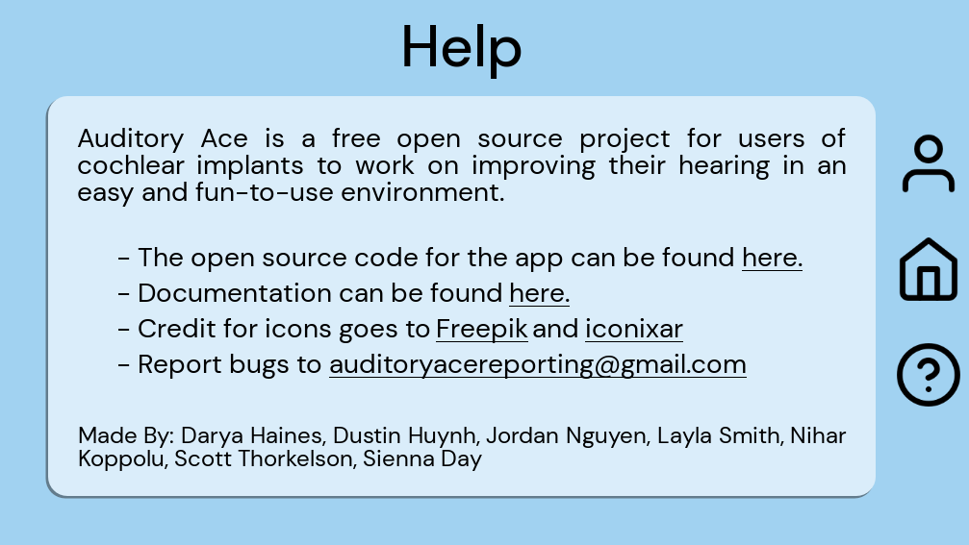

Help page as of 3/10/24

### Introduction

This section contains the following: a description of the application and its purpose.

“Auditory Ace is a free open source project for users of cochlear implants to work on improving their hearing in an easy and fun-to-use environment.”

### Links to important documentation

This section of the help page will provide links to the GitHub Repository, to this documentation, and to all authors of files that are used with credited permission.

### List of links:

<https://github.com/thorkel2/Auditory-Ace>

<https://www.flaticon.com/free-icons/flash-cards>

### Email Address

[auditoryacereporting@gmail.com](mailto:auditoryacereporting@gmail.com)